**Exercise : Creating Microservices for Account and Loan**

**Account Microservice**

**File:AccountController.java**

package com.cognizant.account.controller;

import org.springframework.web.bind.annotation.GetMapping;

import org.springframework.web.bind.annotation.PathVariable;

import org.springframework.web.bind.annotation.RestController;

*@RestController*

public class AccountController {

*@GetMapping*("/accounts/{number}")

public String accountDetails(*@PathVariable* int number) {

String response = "{ number: 00987987973432, type: savings, balance: 234343 }";

return response;

}

}

**Output:**

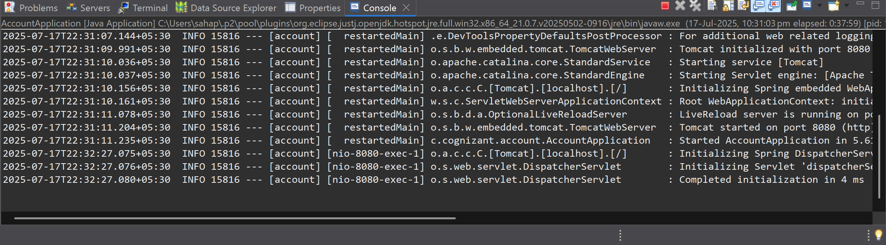

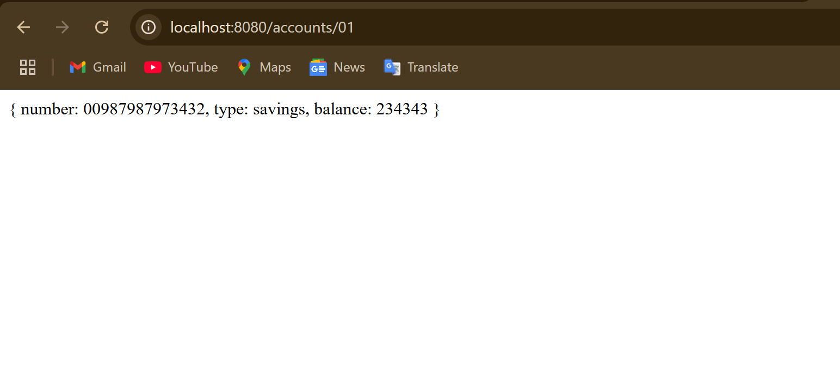

**Loan Microservice**

**File:LoanController.java**

package com.cognizant.loan.controller;

import org.springframework.web.bind.annotation.GetMapping;

import org.springframework.web.bind.annotation.PathVariable;

import org.springframework.web.bind.annotation.RestController;

*@RestController*

public class LoanController {

*@GetMapping*("/loans/{number}")

public String getLoanDetails(*@PathVariable* int number) {

String response = "{ number: \"H00987987972342\", type: \"car\", loan: 400000, emi: 3258, tenure:\r\n"

+ "18 }";

return response;

}

}

**Output:**

